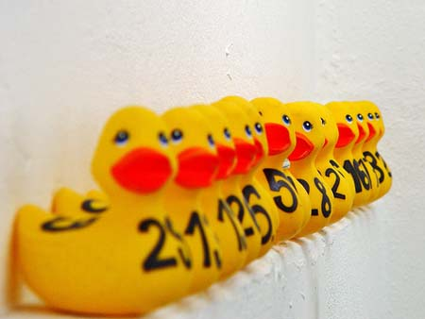Ashby Duck Der by

**Sunday, May 7, 2017, Post Time 1:00 at Damon Pond**

DCR’s Willard Brook State Forest

**Come Join Us for Fun and Prizes!**

Order your ducks Today!

$5.00 per Duck or a

Flock of five for $15.00

Contact Ashby Land Trust

[Doug@AshbyLandTrust.org](mailto:Doug@AshbyLandTrust.org)

978.386.5591

Prizes Include:

* Schooner Sail for 2 in Gloucester
* 873 Café Gift Certificates
* A gallon of Maple Syrup
* And more coming!

** All proceeds to benefit the Ashby Land Trust** 

A 501c3 charitable organization

*Preserving the Natural Resources and Rural Character of Ashby*