Ashby Land Trust Presents

SOLD OUT!!!!

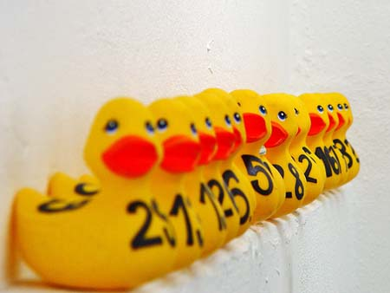2nd Annual Ashby Duck Derby

**Sunday, May 7, 2017, 1PM at Damon Pond**

**Come Join Us For Fun And Prizes!**

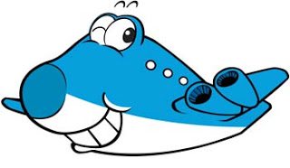

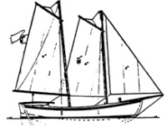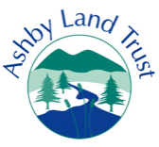

Prizes Include!

* Schooner Sail for 2 in Gloucester!
* 873 Gift Certificates
* Airplane Ride over Ashby!
* More!

All Proceeds to benefit Ashby Land Trust

… *preserving the Natural Resources and Rural Character of Ashby*

Sign Up Today!

$5/Duck or a Flock of 5 for $15

Contact Doug Leab at 978/386-5304